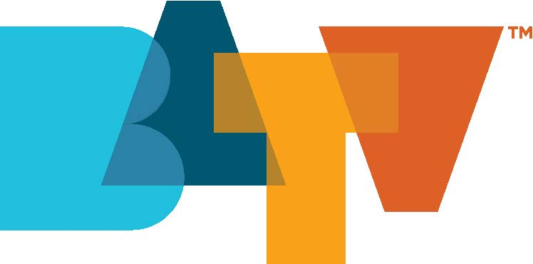
Internship Application

The internship program at BATV is a hands-on, real world program to help train future industry professionals in all aspects of television broadcasting. All interns are expected to work a minimum of fifteen hours per week, arrive on time when scheduled and with a professional attitude. The professional expectations of our interns mirror those of our paid employees, though our internship program is non-paid.
Instructions: Provide all information requested by typing or printing in ink.
Be certain to sign and date the application. An incomplete application may delay action or disqualify you.

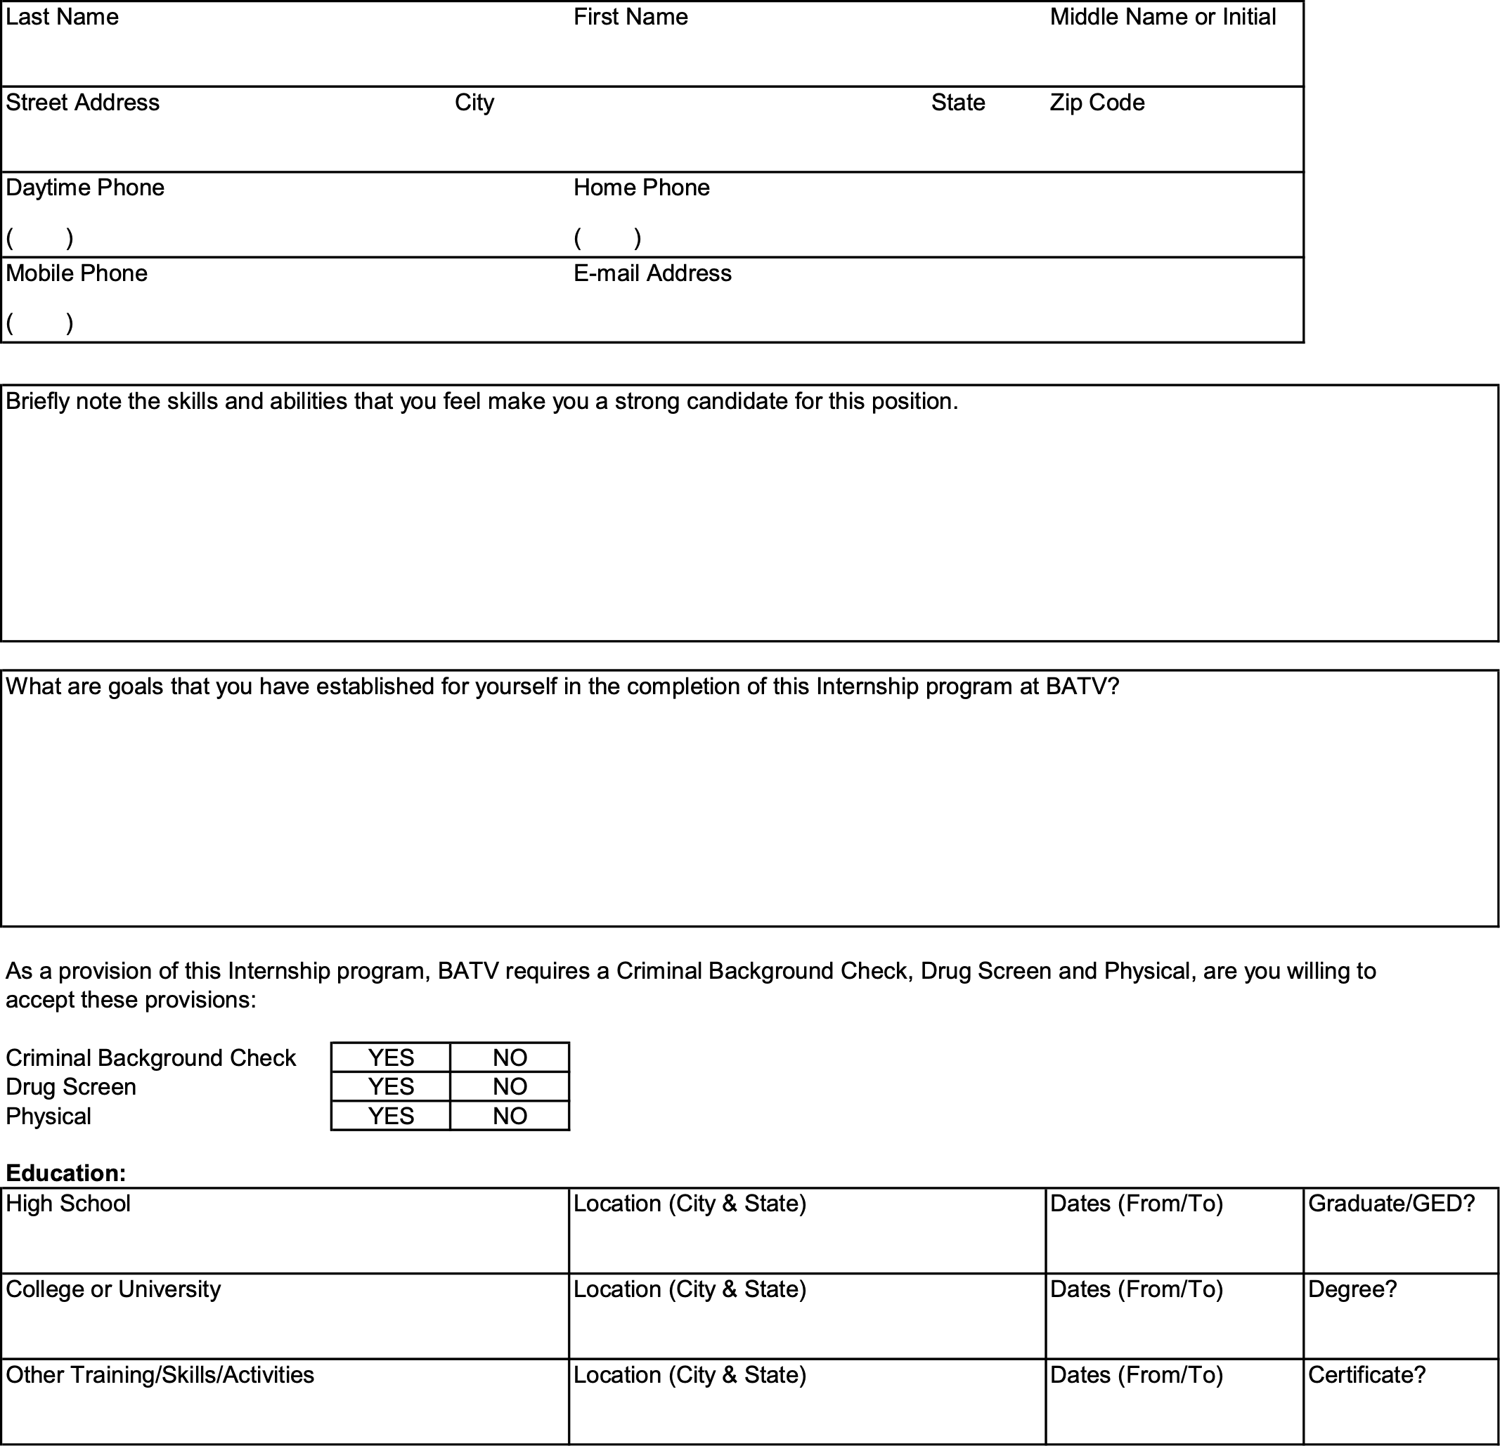

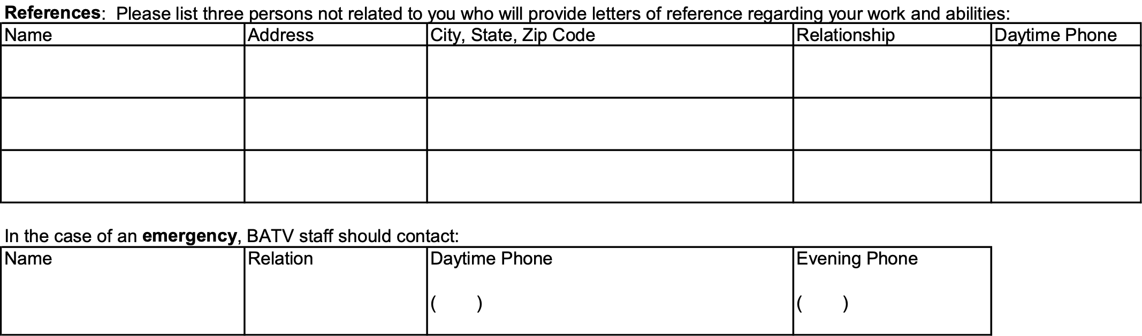

Signature of Applicant ________________________________________ Date ____________________________

